**A**

**Project Report**

**on**

**In partial fulfillment of the requirements for**

**the degree of**

**BACHELOR OF TECHNOLOGY**

**IN**

**INFORMATION TECHNOLOGY**

**Submitted by**

**Under the supervision of**

**MRS.RASHMI NIGOTI**

**(Asst. Professor)**

## BANSAL INSTITUE OF ENGINEERING AND TECHNOLOGY



**Dr A.P.J. Abdul Kalam Technical University**

**Session:2022-2023**

# DECLARATION

I hereby declare that this PARKING MANAGEMENT SYTEM mini project is the record of authentic work carried out by me and my colleagues during the period of one month in college under the guidance of **MRS.RAHMI NIGOTI**(**Assistant Professor**) in partial fulfilment of Degree of Bachelor of Technology.

The information and data given in this synopsis is authentic to the level of my knowledge.

MANJUL PRAKASH SRIVASTAVA

SHOBHIT VERMA

PRABHAT PATEL

BHUMI RAWAT

KUNAL MISHRA

**ACKNOWLEDGEMENT**

I thank the people who were a part of this project in numerous ways, people who gave their unending support right from the stage the project idea was conceived.

The four things that go on to make a successful endeavor are dedication, hard work, patience and correct guidance.

I would like to thank **Mrs. RASHMI NIGOTI** who has always been the source of inspiration and guide for our project .

I also thankful to **Mr. PRAGYA DEEP** our D.B.M.S for all the help she has rendered to ensure the successful completion of the project.

THANK YOU

- MANJUL PRAKASH SRIVASTAVA

- SHOBHIT VERMA

- PRABHAT PATEL

- BHUMI RAWAT

- KUNAL MISHRA

**INTRODUCTION :**

Parking management system for managing the records of the incoming and outgoing vehicles in an parking house

It’s an easy for Admin to retrieve the data if the vehicle has been visited through number he can get that data **.**

Now days in many public places such as malls, multiplex system, hospitals, offices, market areas there is a crucial problem of vehicle parking. The vehicle parking area has many lanes/slots for car parking. So to park a vehicle one has to look for all the lanes. Moreover this involves a lot of manual labour and investment. Instead of vehicle caught in towing the vehicle can park on safe and security with low cost.

Parking control system has been generated in such a way that it is filled with many secure devices such as, parking control gates, toll gates, time and attendance machine, car counting system etc. These features are hereby very necessary nowadays to secure your car and also to evaluate the fee structure for every vehicles entry and exit

The objective of this project is to build a Vehicle Parking management system that enables the time management and control of vehicles using number plate recognition. The system that will track the entry and exit of cars, maintain a listing of cars within the parking lot, and determine if the parking lot is full or not. It will determine the cost of per vehicle according to their time consumption.

**Objectives :**

We can park our vehicle in our own slot by paying.

* Because of that there is no towing problems.
* And our vehicle has been parked as a secure condition.
* There is no risk for vehicle owner for parking the car.
* In case of any damages and problem of vehicle that will claim by parking management.
* As the world is facing many threads daily, robberies are done easily with no track to trace, bomb blasts occur with the use of vehicle, so if a proper system is adopted each and every record can be saved and anyone can be track easily therefore mainly is to make a better and fast software, most important user-friendly
* Maintain records in short time of period.
* Determines the parking area is full or not.
* Enhances the visitor’s experience.

**SYSTEM REQUIREMENT PHASE**

**1.Project Title :**

Parking Management System

**2.Technology:**

* **Backend : python**

**: MySql workbench**

**3.Modules**

**a).Data Records**

**1.Staff records:**  
-Address   
-Contact Number   
-Gender.

**2.User Records:**

**3.Vehicle Records**: - This most important record which focuses in our Vehicle Parking Management System. It stores the essential Vehicle records like:  
-Vehicle Number  
-Vehicle Type  
-Vehicle Entry Time  
-Vehicle Exit Time

**b).Reports**

**1.Vehicle Parking Detail**

**2.Transaction Detail**

**Hardware and software requirement**

|  |  |
| --- | --- |
| PROCESSOR TYPE | Pentium IV or above for optimum performance. |
| SYSTEM RAM | 1.00GB and Above |
| INPUT DEVICE | BASIC KEYBOARD AND TOUCH PAD |
| OUTPUT DEVICE | STANDARD COLOR MONITOR |
| OPERATING SYSTEM | WINDOWS 7,8,10 |
| FRONT END | VISUAL STUDIO 2015 |
| BACK END | SQL SERVER 2008 |

**SYSTEM ANALYSIS PHASE**

1. **Information gathering**

Information gathering is done by interviewing the users and reviewing the existing documents.

* **Interviewing the users:**
* What are the difficulties you are facing in the existing system ?
* What all new things you want to be included in the proposed system ?

1. **User Requirement**

* Need for an application that makes communicating easy and comfortable.
* An application that enables user to park a vehicle with safe and secure.
* Need for an application that is easy to use and widely available and hence a web application

1. **Functional Requirement**

* Admin need to enter all details for registration.
* Admin need to insert all details about customer and vehicle.
* Admin need to save all the details of customer and vehicle.
* Admin can retrieve the details of customer.
* Admin must generate a report for payment.

1. **Non-functional Requirement**

* Usability: These website has appropriate user interface and adequate information to guide the user in order to use the website.
* Portability: The website is portable as it is online website running across the net
* Flexibility: It is very flexible

**SYSTEM PLANNING PHASE**

**1.Process model :**

**-iterative model diagram**

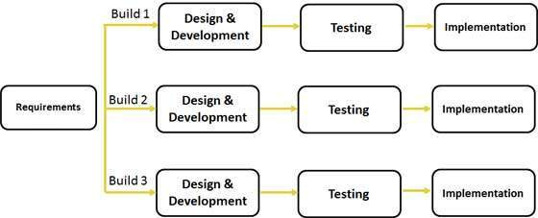

**2. Feasibility Study**

**Economic feasibility**

Economic feasibility attempts to weigh the cost of developing and implementing a new system, against the benefits that would accurate from having the new system in place. This feasibility study gives the top management the economic justification for the new system

**Schedule feasibility**

Schedule Feasibility means that the project can be completed on time

The project does not have a deadline but according to the proposed system the development process is on schedule. Therefore it is feasible.

**Operational feasibility**

Proposed project is beneficial only if it can be turned into information systems that will meet the organization operating requirements. Simply stated, this test of feasibility asks if the system will work when it is developed and installed.

**SYSTEM DESIGN PHASE**

**ER-Diagram:**

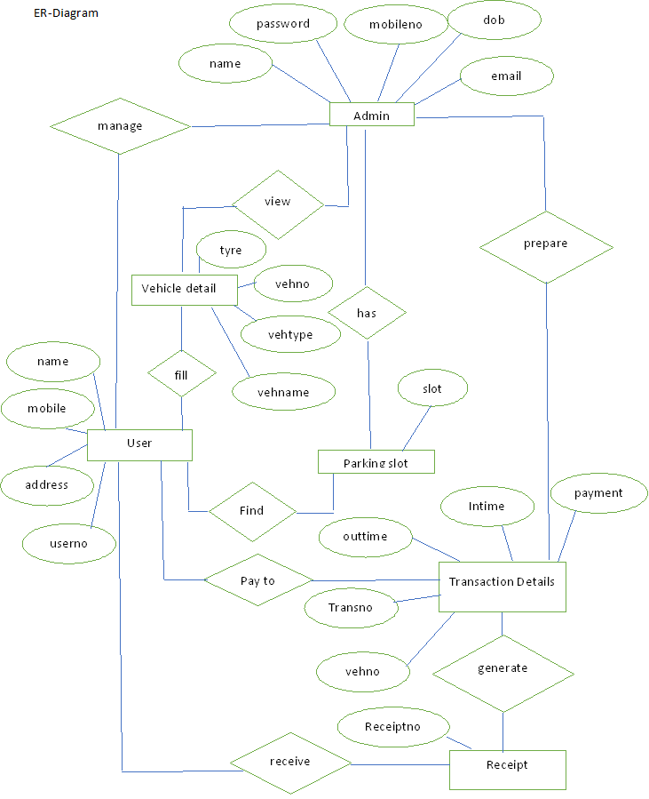

**Class diagram :**

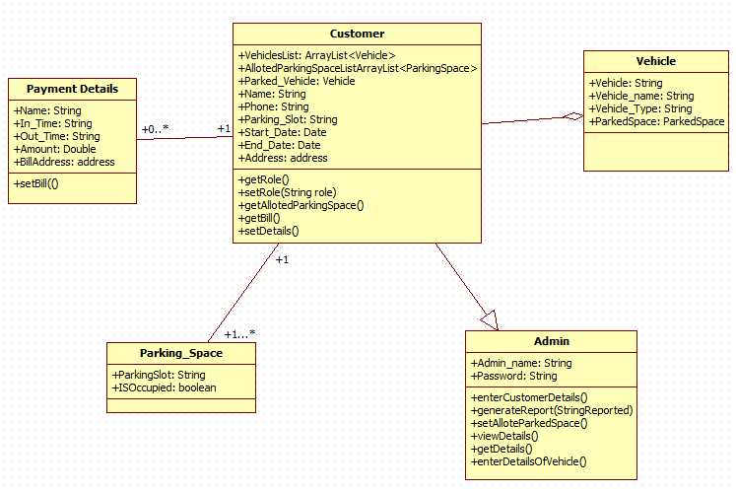

**Use case Diagram :**

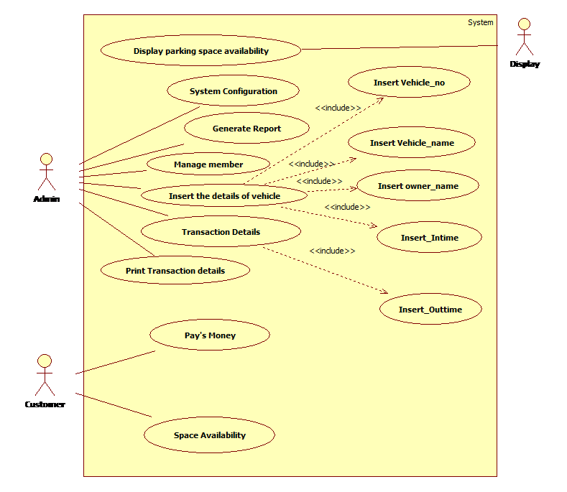

**Activity Diagram**

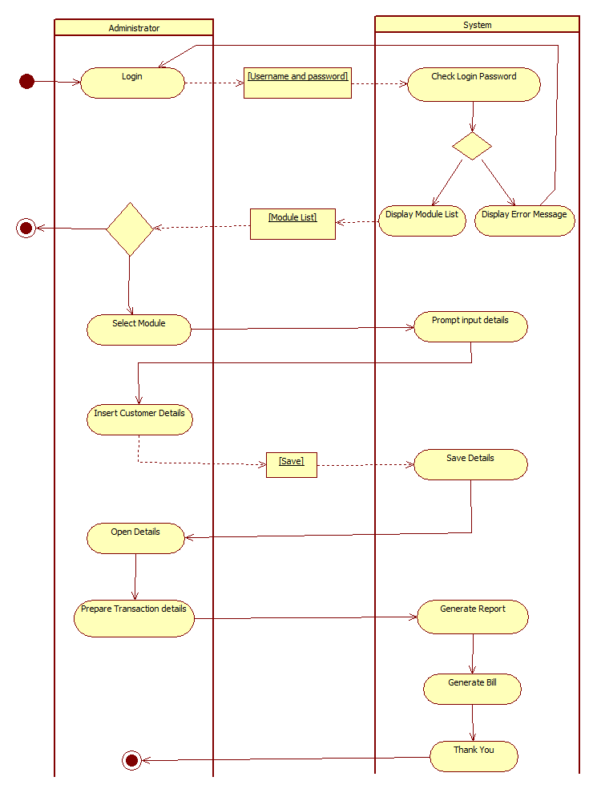

**Sequence diagram** 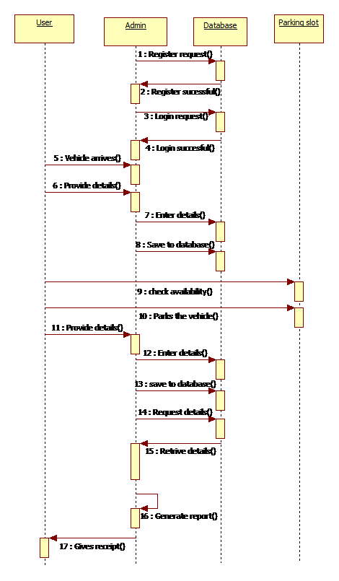

**SYSTEM IMPLEMENTATION**

**PHASE**

**1. Cost Benefit Analysis:**

Cost benefit analysis (CBA) estimates and total up the equivalent money value of the benefits and the cost invested to for implementation the software .Cost benefit analysis (CBA) is the weighing scale approach to decision-making. All the plus points (such as cash flow and other intangible benefits) are put on one side all the minus points (the cost and disadvantages) are put on the other side. Both sides should be weighed and benefits should be evaluated.

**Cost Estimation:**

A **cost estimate** is the approximation of the **cost** of a program, project, or operation. The **cost estimate** is the product of the **cost estimating** process. The **cost estimate** has a single total value and may have identifiable component values.

For a given set of requirements, it is desirable to know how much it will cost to develop the software to satisfy a given requirement, and how much time development will take. The cost of a project is a function of many parameters. Foremost among them is the size of the project. Other factors that effects the cost are programmer ability, experience of the developers in the area , complexity of the project, and reliability requirements of the software, hardware and human resources

**Benefits:**

* Improves business processes leading to annual cost decrease.
* Due to availability of information, better decision making is possible leading to additional cash flows.

**Development Cost:**

|  |  |  |
| --- | --- | --- |
|  | Tools Requirement | Cost |
| **Hardware** | 1 Computer | 29000 |
|  | Installation Charges | 2000 |
|  | **Total** | 31000 |
| **Software and Licenses** | Asp. Net (Visual studio 2015) | 5000 |
|  | SQL Server 2008 | 2000 |
|  | **Total** | 7000 |

**Operational cost**

|  |  |  |
| --- | --- | --- |
| ToolsName | Maintenance | Cost |
| Operational | HardwareMaintenance | 2500 |
|  | Software Maintenance | 2500 |
|  | Total | 5000 |

**SOURCE CODE:**

**#Import Time**

**import time**

**Vehicle_Number=['XXXX-XX-XXXX']**

**Vehicle_Type=['Bike']**

**vehicle_Name=['Intruder']**

**Owner_Name=['Unknown']**

**Date=['22-22-3636']**

**Time=['22:22:22']**

**bikes=100**

**cars=250**

**bicycles=78**

**#2. Create a while loop block to display the options in Vehicle Parking Management Project**

**def main():**

**global bikes,cars,bicycles**

**try:**

**while True:**

**print("-----------------------------------------------------")**

**print("\t\tParking Management System")**

**print("-------------------------------------------------------")**

**print("1.Vehicle Entry")**

**print("2.Remove Entry" )**

**print("3.View Parked Vehicle ")**

**print("4.View Left Parking Space ")**

**print("5.Amount Details ")**

**print("6.Bill")**

**print("7.Close Programme ")**

**print("+---------------------------------------------+")**

**ch=int(input("\tSelect option:"))**

**#code for vechile number entry:**

**if ch==1:**

**no=True**

**while no==True:**

**Vno=input("\tEnter vehicle number (XXXX-XX-XXXX) - ").upper()**

**if Vno=="":**

**print("###### Enter Vehicle No. ######")**

**elif Vno in Vehicle_Number:**

**print("###### Vehicle Number Already Exists")**

**elif len(Vno)==12:**

**no=not True**

**Vehicle_Number.append(Vno)**

**else:**

**print("###### Enter Valid Vehicle Number ######")**

**#code to enter the vechile type**

**typee=True**

**while typee==True:**

**Vtype=str(input("\tEnter vehicle type(Bicycle=A/Bike=B/Car=C):")).lower()**

**if Vtype=="":**

**print("###### Enter Vehicle Type ######")**

**elif Vtype=="a":**

**Vehicle_Type.append("Bicycle")**

**bicycles-=1**

**typee=not True**

**elif Vtype=="b":**

**Vehicle_Type.append("Bike")**

**bikes-=1**

**typee=not True**

**elif Vtype=="c":**

**Vehicle_Type.append("Car")**

**cars-=1**

**typee=not True**

**else:**

**print("###### Please Enter Valid Option ######")**

**#code to enter the vechile name**

**name=True**

**while name==True:**

**vname=input("\tEnter vehicle name - ")**

**if vname=="":**

**print("########Please Enter Vehicle Name ########")**

**else:**

**vehicle_Name.append(vname)**

**name=not True**

**#code to enter the owners name:**

**o=True**

**while o==True:**

**OName=input("\tEnter owner name - ")**

**if OName=="":**

**print("###### Please Enter Owner Name ######")**

**else:**

**Owner_Name.append(OName)**

**o=not True**

**#code to enter the date and time:**

**d=True**

**while d==True:**

**date=input("\tEnter Date (DD-MM-YYYY) - ")**

**if date=="":**

**print("###### Enter Date ######")**

**elif len(date)!=10:**

**print("###### Enter Valid Date ######")**

**else:**

**Date.append(date)**

**d=not True**

**t=True**

**while t==True:**

**time=input("\tEnter Time (HH:MM:SS) - ")**

**if t=="":**

**print("###### Enter Time ######")**

**elif len(time)!=8:**

**print("###### Please Enter Valid Time ######")**

**else:**

**Time.append(time)**

**t=not True**

**print("\n............................................................Record")**

**#code to remove the entry from register:**

**elif ch==2:**

**no=True**

**while no==True:**

**Vno=input("\tEnter vehicle number to Delete(XXXX-XX-XXXX) - ").upper()**

**if Vno=="":**

**print("###### Enter Vehicle No. ######")**

**elif len(Vno)==12:**

**if Vno in Vehicle_Number:**

**i=Vehicle_Number.index(Vno)**

**Vehicle_Number.pop(i)**

**Vehicle_Type.pop(i)**

**vehicle_Name.pop(i)**

**Owner_Name.pop(i)**

**Date.pop(i)**

**Time.pop(i)**

**no=not True**

**print("\n............................................................Removed Sucessfully..................................................................")**

**elif Vno not in Vehicle_Number:**

**print("###### No Such Entry ######")**

**else:**

**print("Error")**

**else:**

**print("###### Enter Valid Vehicle Number #####")**

**#code to display the vechiles present in parking area**

**elif ch==3:**

**count=0**

**print("----------------------------------------------------------------------------------------------------------------------")**

**print("\t\t\t\tParked Vehicle")**

**print("----------------------------------------------------------------------------------------------------------------------")**

**print("Vehicle No.\tVehicle Type Vehicle Name\t Owner Name\t Date\t\tTime")**

**print("----------------------------------------------------------------------------------------------------------------------")**

**for i in range(len(Vehicle_Number)):**

**count+=1**

**print(Vehicle_Number[i],"\t ",Vehicle_Type[i],"\t ",vehicle_Name[i],"\t ",Owner_Name[i]," " ,Date[i]," ",Time[i])**

**print("----------------------------------------------------------------------------------------------------------------------")**

**print("------------------------------------------ Total Records - ",count,"-------------------------------------------------------")**

**print("-------------------------------------------------------------------")**

**#code for spaces left in parking area:**

**elif ch==4:**

**print("----------------------------------------------------------------------------------------------------------------------")**

**print("\t\t\t\tSpaces Left For Parking")**

**print("----------------------------------------------------------------------------------------------------------------------")**

**print("\tSpaces Available for Bicycle - ",bicycles)**

**print("\tSpaces Available for Bike - ",bikes)**

**print("\tSpaces Available for Car - ",cars)**

**print("---------------------------------------------------------------------")**

**#code for displaying the parking rate:**

**elif ch==5:**

**print("----------------------------------------------------------------------------------------------------------------------")**

**print("\t\t\t\tParking Rate")**

**print("----------------------------------------------------------------------------------------------------------------------")**

**print("*1.Bicycle Rs20 / Hour")**

**print("*2.Bike Rs40/ Hour")**

**print("*3.Car Rs60/ Hour")**

**print("---------------------------------------------------------------------")**

**#code for generate bills for different type of vechils parked:**

**elif ch==6:**

**print(".............................................................. Generating Bill ..........................................................................")**

**no=True**

**while no==True:**

**Vno=input("\tEnter vehicle number to Delete(XXXX-XX-XXXX) - ").upper()**

**if Vno=="":**

**print("###### Enter Vehicle No. ######")**

**elif len(Vno)==12:**

**if Vno in Vehicle_Number:**

**i=Vehicle_Number.index(Vno)**

**no=not True**

**elif Vno not in Vehicle_Number:**

**print("###### No Such Entry ######")**

**else:**

**print("Error")**

**else:**

**print("###### Enter Valid Vehicle Number ######")**

**print("\tVehicle Check in time - ",Time[i])**

**print("\tVehicle Check in Date - ",Date[i])**

**print("\tVehicle Type - ",Vehicle_Type[i])**

**inp=True**

**amt=0**

**while inp==True:**

**hr=input("\tEnter No. of Hours Vehicle Parked - ").lower()**

**if hr=="":**

**print("###### Please Enter Hours ######")**

**elif int(hr)==0 and Vehicle_Type[i]=="Bicycle":**

**amt=20**

**inp=not True**

**elif int(hr)==0 and Vehicle_Type[i]=="Bike":**

**amt=40**

**inp=not True**

**elif int(hr)==0 and Vehicle_Type[i]=="Car":**

**amt=60**

**inp=not True**

**elif int(hr)>=1:**

**if Vehicle_Type[i]=="Bicycle":**

**amt=int(hr)*int(20)**

**inp=not True**

**elif Vehicle_Type[i]=="Bike":**

**amt=int(hr)*int(40)**

**inp=not True**

**elif Vehicle_Type[i]=="Car":**

**amt=int(hr)*int(60)**

**inp=not True**

**print("\t Parking Charge - ",amt)**

**ac=18/100*int(amt)**

**print("\tAdd. charge 18 % - ",ac)**

**print("\tTotal Charge - ",int(amt)+int(ac))**

**print("..............................................................Thank you for using our service...........................................................................")**

**a=input("\tPress Any Key to Proceed - ")**

**elif ch==7:**

**print("..............................................................Thank you for using our service...........................................................................")**

**print(" **********(: Bye Bye :)**********")**

**break**

**quit**

**except:**

**main()**

**main()**

**Conclusion**

This Project is minimizing the task of parking a vehicle by paying and saying some details about customer and vehicle to save data .In this the vehicle is parked as a safe and secure. This project is done as Efficient as possible

Hereby I, the Student of B.TECH(IT) 5th Semester concludes that the project was completely and slowly developed by my project group. I also conclude that this project has helped us gain more knowledge about the topic that we are indulged ourselves into “ Visual Studio ”. I would be glad to enhance and promote this project if given chance and help ourselves and society in the near future

The developed application is tested with sample inputs and outputs obtained in according to the requirement. Even though I have tried our level best to make it a dream project. Due to time constraints I could not add more facilities to it.

The efficiency of the developed system can be enhanced with some minor modifications. Future development can be made in proposed system by integration more services like:

* It can be implemented through web pages.
* New effectives modules can be added time to time

**Scopes For Expansion**

This is the modern age. Many people have vehicles. Vehicle is now a basic need. Every place is under the process of urbanization. There are many corporate offices and shopping centers etc. There are many recreational places where people used to go for refreshment. So, all these places need a parking space where people can park their vehicles safely and easily. Every parking area needs a system that records the detail of vehicles to give the facility. These systems might be computerized or non-computerized. With the help of computerized system we can deliver a good service to customer who wants to park their vehicle into the any organization’s premises.

**Enhancement to create a Bigger and Better System**

These enhancements deal with what would be required in a new improved, bigger and better system

* In future if when a vehicle enters into the parking area there should be one sensor in which the user can easy identify from outside only Is there parking is full or empty or space is allocated.
* In future the vehicle can be parked by machines